=EPMDimensionOverride("000";"TIME";"BAS("&D2&")")
=EPMMemberProperty(;C6;"BYEAR")&".TOTAL"
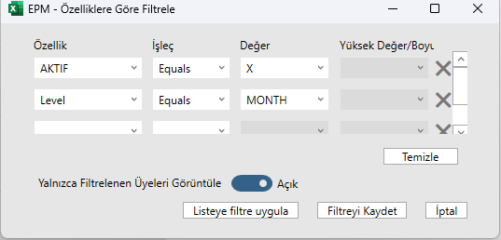 | 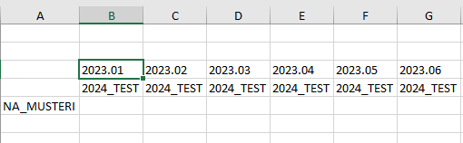

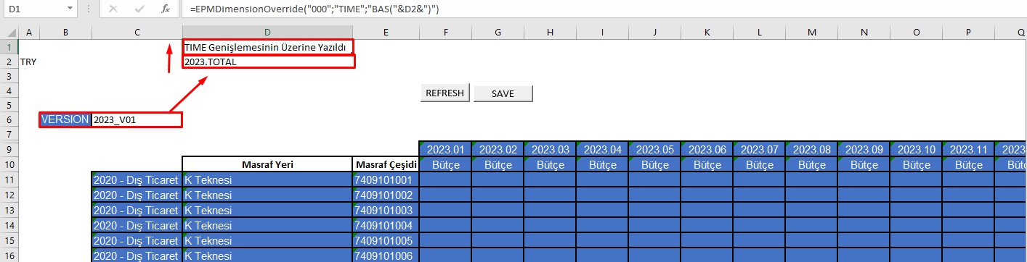

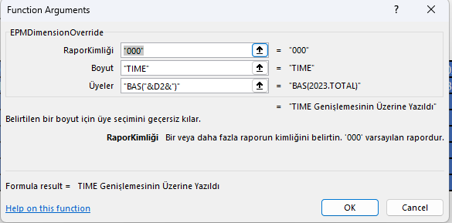

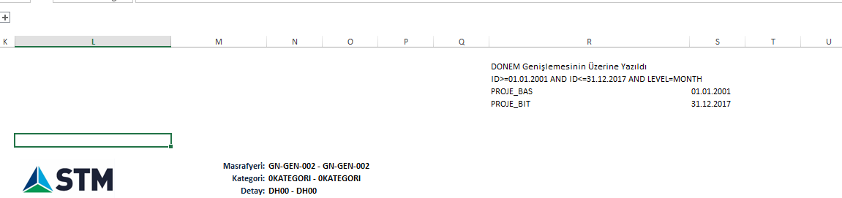

=EPMDimensionOverride("000","DONEM",R51)
="ID>="&S52&" AND ID<="&S53&" AND LEVEL=MONTH"
PROJE_BAS = =EPMMemberProperty(,N58,R52) | N58 = =EPMContextMember(,"MASRAFYERI",,1) = GN-GEN-002
PROJE_BIT = =EPMMemberProperty(,N58,R53) | N58 = =EPMContextMember(,"MASRAFYERI",,1) = GN-GEN-002

